**GOLANG Programming Questions**

1. Program to print the Factors of a Number N

**CODE:**

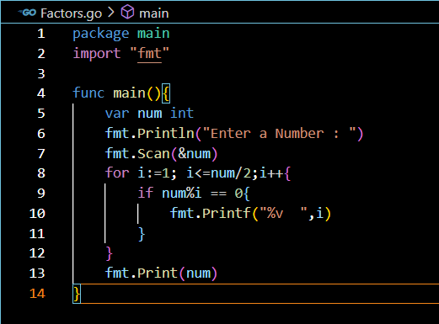

**OUTPUT:**

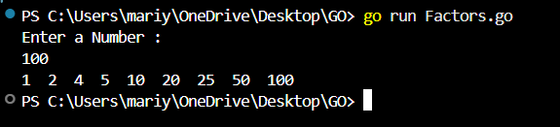

1. Program to check whether given Integer is Prime or Not

**CODE:**

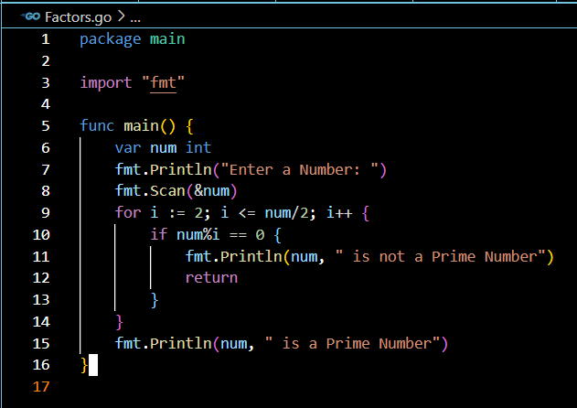

**OUTPUT:**

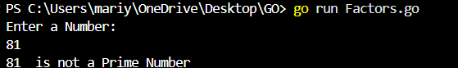

1. [Program to print the Prime numbers between two intervals](https://decodeschool.com/Problem-Solving/Working-with-Factors/Program-to-print-the-Prime-numbers-between-two-intervals)

**CODE:**

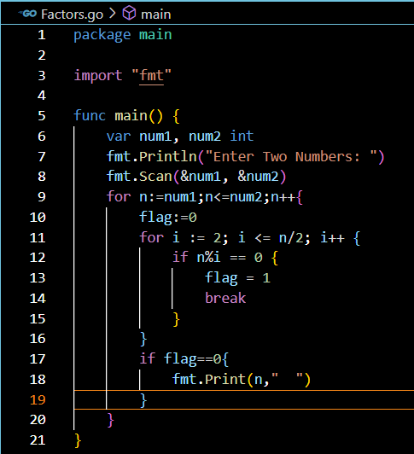

**OUTPUT:**

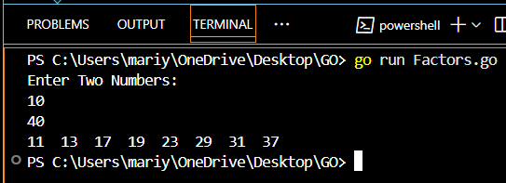

1. [Program to print the Prime Factors of N](https://decodeschool.com/Problem-Solving/Working-with-Factors/Program-to-print-the-Prime-Factors-of-N)

**CODE:**

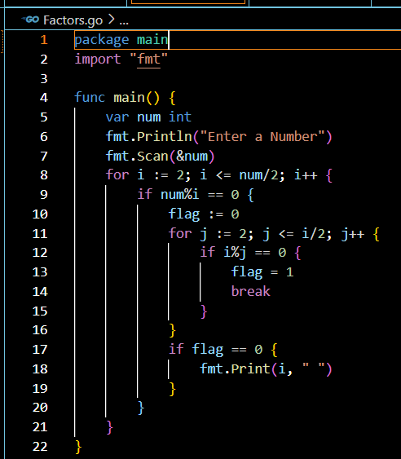

**OUTPUT:**

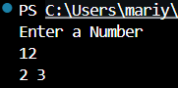

1. [Program to check whether given Integer is perfect number or not](https://decodeschool.com/Problem-Solving/Working-with-Factors/Program-to-check-whether-given-Integer-is-perfect-number-or-not)

**CODE:**

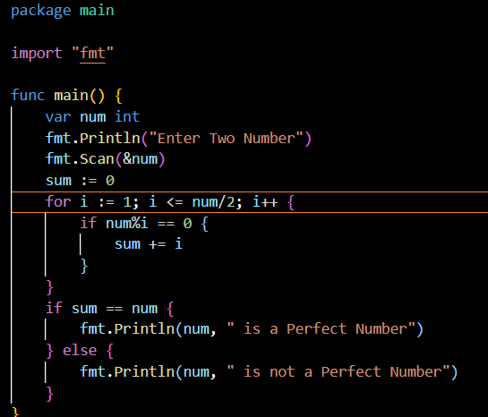

**OUTPUT:**



1. [Program to print the perfect numbers between two intervals](https://decodeschool.com/Problem-Solving/Working-with-Factors/Program-to-print-the-perfect-numbers-between-two-intervals)

**CODE:**

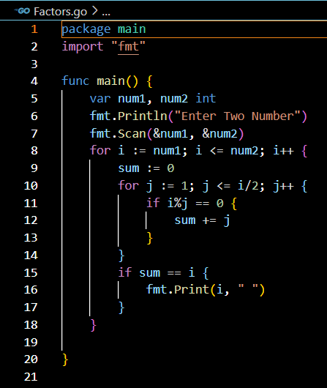

**OUTPUT:**

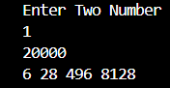

1. [Program to check whether given Integer is Perfect Square or not](https://decodeschool.com/Problem-Solving/Working-with-Factors/Program-to-check-whether-given-Integer-is-Perfect-Square-or-not)

**CODE:**

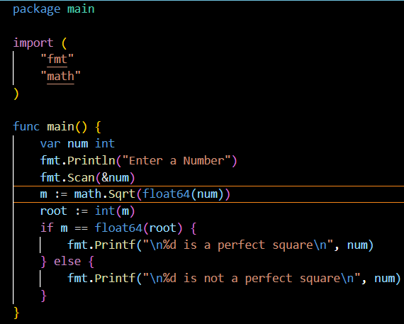

**OUTPUT:**

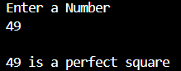

1. [Program to Print the Perfect squares between two intervals](https://decodeschool.com/Problem-Solving/Working-with-Factors/Program-to-Print-the-Perfect-squares-between-two-intervals)

**CODE:**

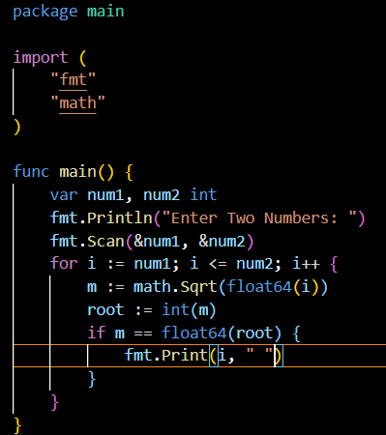

**OUTPUT:**

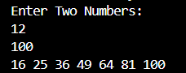

1. [Program to check whether given Integer is whether integer is power of 2 or not](https://decodeschool.com/Problem-Solving/Working-with-Factors/Program-to-check-whether-given-Integer-is-whether-integer-is-power-of-2-or-not)

**CODE:**

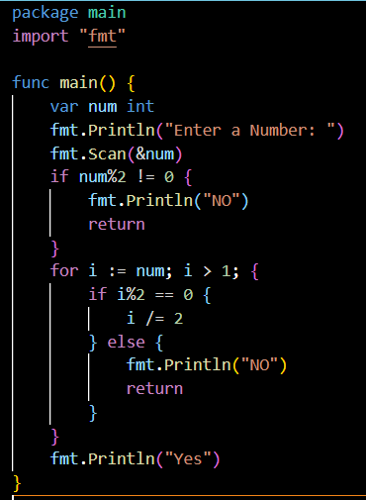

**OUTPUT:**

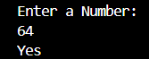

1. [Program to find GCD of given numbers](https://decodeschool.com/Problem-Solving/Working-with-Factors/Program-to-find-GCD-of-given-numbers)

**CODE:**

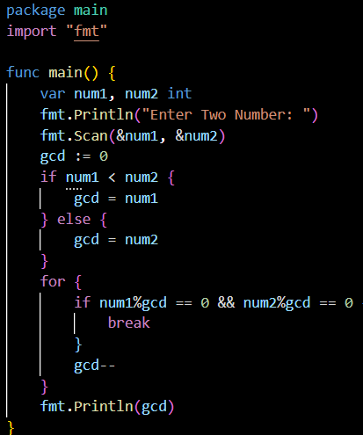

**OUTPUT:**

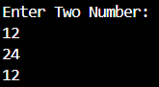

1. [Program to find LCM of given numbers](https://decodeschool.com/Problem-Solving/Working-with-Factors/Program-to-find-LCM-of-given-numbers)

**CODE:**

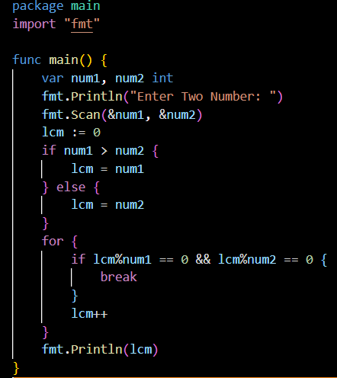

**OUTPUT:**

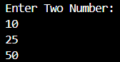

1. [C Program to check whether the given digit is occurred in a Number](https://decodeschool.com/Problem-Solving/Working-with-Digits/C-Program-to-check-whether-the-given-digit-is-occurred-in-a-Number)

**CODE:**

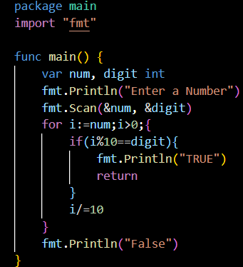

**OUTPUT:**

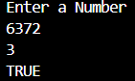

1. [C Program to count the occurence of digit](https://decodeschool.com/Problem-Solving/Working-with-Digits/C-Program-to-count-the-occurence-of-digit)

**CODE:**

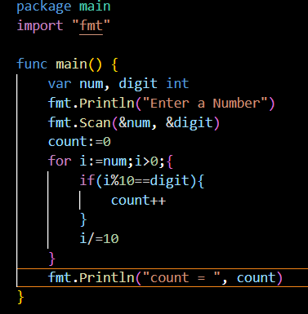

**OUTPUT:**

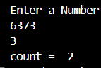

1. [C Program to find the first digit of a number](https://decodeschool.com/Problem-Solving/Working-with-Digits/C-Program-to-find-the-first-digit-of-a-number)

**CODE:**

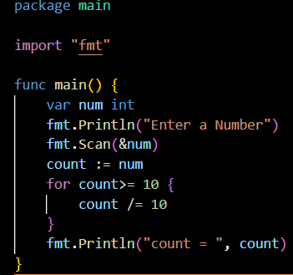

**OUTPUT:**



1. [C Program to Count the digits in the given number.](https://decodeschool.com/Problem-Solving/Working-with-Digits/C-Program-to-Count-the-digits-in-the-given-number)

**CODE:**

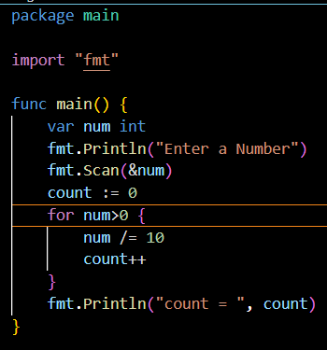

**OUTPUT:**

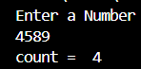

1. [C Program to calculate sum of digits.](https://decodeschool.com/Problem-Solving/Working-with-Digits/C-Program-to-calculate-sum-of-digits)

**CODE:**

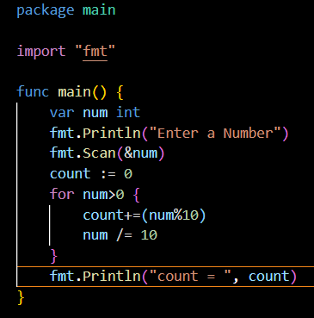

**OUTPUT:**

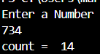

1. [C Program to calculate product of digits.](https://decodeschool.com/Problem-Solving/Working-with-Digits/C-Program-to-calculate-product-of-digits)

**CODE:**

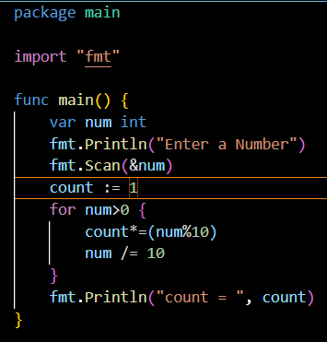

**OUTPUT:**

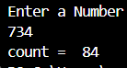

1. [C Program to reverse the digits of an number](https://decodeschool.com/Problem-Solving/Working-with-Digits/C-Program-to-reverse-the-digits-of-an-number)

**CODE:**

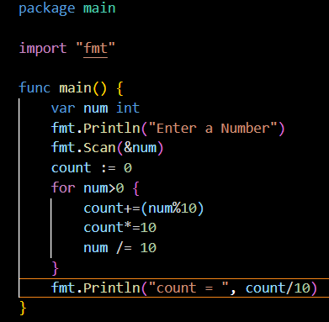

**OUTPUT:**

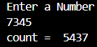

1. [C Program to check whether given Integer is Palindrome or Not](https://decodeschool.com/Problem-Solving/Working-with-Digits/C-Program-to-check-whether-given-Integer-is-Palindrome-or-Not)

**CODE:**

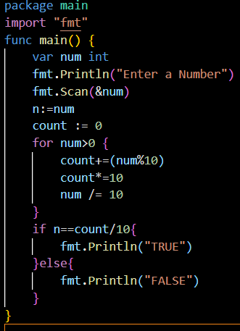

**OUTPUT:**



1. [C Program to check whether given Integer is Armstrong or Not](https://decodeschool.com/Problem-Solving/Working-with-Digits/C-Program-to-check-whether-given-Integer-is-Armstrong-or-Not)

**CODE:**

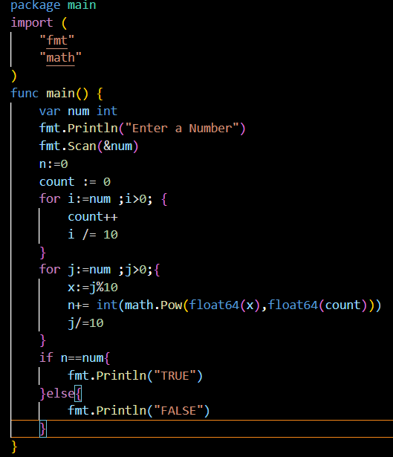

**OUTPUT:**

